Generic—Chapter Template

Front material: Title page, Acknowledgments etc.
- Notes:
- This document is formatted for one person’s thesis using APA style with some variations.
- All headings are automatic styles and their formatting can be changed by changing the style. This will change all headings of the same level. No manual changes should be made to any headings.
- This document assumes that all the thesis is in one Word document. This is probably the best way to keep things simple with respect to making sure all the thesis is formatted correctly. Otherwise, if the thesis is in a number of documents, any global change (e.g., to a heading style) needs to be identically repeated in every other document. With all the thesis in one document it is still easy to extract one section/chapter at a time, either by copying and pasting or by going to the print dialogue, choosing the page numbers and then saving as a pdf.
- This style in red that you are reading now is called “red” and is useful for making notes that will not be included in the final thesis. It is easy to do a find and replace on all “red” to delete it.

Table of Contents
Front material: Title page, Acknowledgments etc. 1
Table of Contents 2
List of Appendices 3
List of Tables 4
List of Figures 5
Chapter 7: The Systems: Experiences with Health, Education, and Government Bodies 6
7.1 Introduction 6
7.2 “There Is No Clear Road …”: Issues with Diagnosis and Healthcare Access 6
7.2.1 Knowledge of health professionals 6
Chapter 8: Next chapter 8
Appendices 8
Appendix 1: An Appendix 8
Appendix 2: Another Appendix 8
References 9
Styles Used in This Document 10
Chapter 9: HEADING 1 for chapters (autonumbered) and main headings 10
9.1 HEADING 2 for Subheadings in Title Case (Autonumbered) 10
9.1.1 HEADING 3 for level 3 (autonumbered but not title case) 10
Appendix 3: APPENDIX Style is the Same as Heading 2 (autonumbered) 10

List of Appendices
Appendix 1: An Appendix 8
Appendix 2: Another Appendix 8
Appendix 3: APPENDIX Style is the Same as Heading 2 (autonumbered) 10

List of Tables
Table 1: Here’s a table 7
Table 2: TABLE style for titles of tables, which go above the table 10

List of Figures
Figure 1: Geoff’s drawing of what makes him sad and angry 7
Figure 2: FIGURE style for titles of figures, which go below the figure. You don’t need to type in “Figure 1” as it will automatically do that and number them. 10

The Systems: Experiences with Health, Education, and Government Bodies

Introduction
Whilst Chapter 6 focused on the experiences, health outcomes, and coping strategies of individuals with Asperger syndrome (AS) and their families, Chapter 7 focuses specifically on the families’ experiences within the healthcare, education, and government systems. Blah blah …

“There Is No Clear Road …”: Issues with Diagnosis and Healthcare Access
Judy said that along the road towards her son’s diagnosis she felt, “I am getting all these pieces to a puzzle, but I want to know what the big picture is.” Often families lacked knowledge about their entitlements: “I didn’t know I was entitled to a carer’s allowance! I had no idea about any of this stuff!” [Jen]. Blah blah …

Knowledge of health professionals
The lack of knowledge of health professionals was followed up by the lack of ability to handle such a disorder. This led many children in this research to be mistreated shortly after they were diagnosed and families at this time were unsupported.
So then he said yes, we believe he has Asperger’s/ADHD; we think you should start him on Ritalin. Blah blah and lots more blahs to make this up to 40 words. Well that was disastrous, because within eight weeks he has lost 4 kg. [Jen]
- Note the “4 kg” there: 1. the 4 is not four because it uses maths/science shorthand. Otherwise it would be four kilograms. 2. There is a space between the number and the symbol kg.
Being a psychiatrist all that they do is diagnose and prescribe ... they don’t assist you with day-to-day living. Blah blah and lots more blahs to make this up to 40 words. They talk to you during your session, make observations, then give you your drugs. [Don]
For both Jill and Jen, their confidence and knowledge of the healthcare field was their ticket to support: “I didn’t feel as intimidated as easily with hierarchies” [Jill]. “I’ve had 10 years of experience, I’m not a young player, and I’m not scared and naive to put my hand up and say, this isn’t working” [Jen].

Bullying
Geoff was desperate to fit in with his peers at primary school. However, his differences were clear to other students and he was often bullied by them. His father Bob said: “It’s almost like they are putting a target on their forehead and saying ‘have a go at me!’” In figure 1, below, there is a picture drawn by Geoff, aged 11, diagnosed with AS.
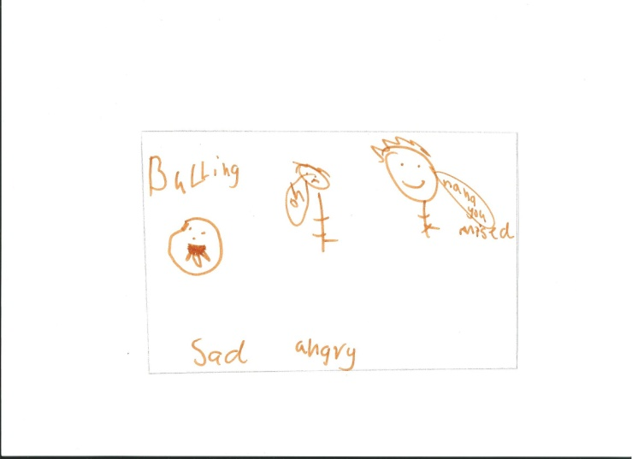
- Geoff’s drawing of what makes him sad and angry
Some of these individuals perceived themselves as coping in this school setting, where they fought against staff assistance in an attempt to prove that they were not ‘stupid,’ ‘retarded,’ or ‘disabled,’ and they could, in fact, fit in to this mainstream environment.
- Here’s a table
This is TABLETEXT style | And this
And this too

Miller says that AS children are “difficult to handle” (Miller, 1988, p. 56). He also says that
there are seven ways AS children can stress their parents. The list is … I can fill out the 40 words needed to make this a block quotation, there are seven ways I can fill out the 40 words needed to make this a block quotation, there are now over 40 words here. (Miller, 1988, p. 123)
- each of the following two main headings would start on new pages in the actual thesis

Next chapter

Appendices
- An Appendix
Blah blah
- Another Appendix
Blah

References
- Note: all editing of the punctuation for this list needs to happen in Endnote.
- Examples copied from http://www.lib.latrobe.edu.au/referencing-tool/apa-6
Book with one author
Benesch, S. (2001). Critical English for academic purposes: Theory, politics, and practice. Mahwah, NJ: Lawrence Erlbaum.
American Psychiatric Association. (2013). Diagnostic and statistical manual of mental disorders (5th ed.). Washington, DC: Author.
Book with two authors
Grant, P. R., & Grant, B. R. (2008). How and why species multiply: The radiation of Darwin’s finches. Princeton, NJ: Princeton University Press.
Online article with DOI
Kingsley, M., Penas-Ruiz, C., Terry, C., & Russell, M. (2014). Effects of carbohydrate-hydration strategies on glucose metabolism in recreational players. Journal of Science and Medicine in Sport, 17(2), 239-243. doi:http://dx.doi.org/10.1016/j.jsams.2013.04.010
Online article without DOI
Cueto-Rojasa, H. F. (2010). Interferon-a 2b quantification in inclusion bodies using Reversed Phase-Ultra Performance Liquid Chromatography (RP-UPLC). Journal of Chromatography B, 878, 1019-1023. Retrieved from
http://0-www.sciencedirect.com.alpha2.latrobe.edu.au/science
Document from a website
Australian Council for Educational Research. (2010). Doing more for learning: Enhancing engagement and outcomes. Retrieved from http://ausse.acer.edu.au/images/docs/AUSSE_2009_Student_Engagement_Report.pdf
Webpage
Center for Bioethics. (2009). Ethics and pharmaceutical marketing. Retrieved from http://www.ahc.umn.edu/bioethics/research/pharm/home.html

Styles Used in This Document

HEADING 1 for chapters (autonumbered) and main headings

HEADING 2 for Subheadings in Title Case (Autonumbered)

HEADING 3 for level 3 (autonumbered but not title case)

HEADING 4 for level 4
Q for block quotations of more than 40 words. Q for block quotations of more than 40 words. Q for block quotations of more than 40 words. Q for block quotations of more than 40 words. I.e. getting close to four lines.
- RED for notes not to be included in final document
- FIGURE style for titles of figures, which go below the figure. You don’t need to type in “Figure 1” as it will automatically do that and number them.
- TABLE style for titles of tables, which go above the table
- LIST BULLET for bulleted lists and numbered lists. To number a list, choose List Bullet style then click the numbering thingy in the toolbar.
REFLIST for the reference list which has a hanging indent (2nd and subsequent lines) like this paragraph does.
TABLETEXT style for all text in tables
NORMAL text for the rest of the document
- APPENDIX Style is the Same as Heading 2 (autonumbered)

